Assignments: Exponential and Logarithmic Functions
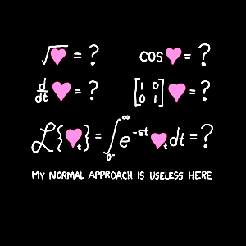
Mr. Daniel Miller – PreCalculus
Daniel.Miller@hvs.org
248-676-8320 ext. 7153
www.mrdmillersclassroom.weebly.com

 | 3.1 |  | 3.2 | 3.3 |  |  | 3.4 | 3.5
Wednesday  2-17-16 | 1 – 51 EOO
Thursday  2-18-16 |  |  | 1 – 99 ETO
Friday  2-19-16 |  |  |  | 1 – 81 EOO
Monday  2-22-16 | SAT Prep
Tuesday  3-23-16 |  |  |  |  |  |  | 1 – 47 odd
Wednesday  2-24-16 |  |  |  |  |  | 48-89 odd
Thursday  2-25-16 |  |  |  |  |  |  |  |  | 9 – 33 odd
Friday  2-26-16 |  |  |  |  |  |  |  |  | 35-49 odd
Monday  2-29-16 | Review Chapter 3 Part I: No Calculator Allowed
Tuesday  3-1-16 | Test Chapter 3 part I: No Calculator Allowed
Wednesday  3-2-16 | Review Chapter 3 Part II: Calculator Allowed
Thursday  3-3-16 | Test: Chapter 3 Part II: Calculator Allowed

Note: Review Sheets will not be turned in, but you should be doing them to practice for the test.

