Assignments: Exponential and Logarithmic Functions
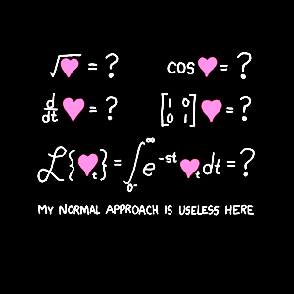
Mr. Miller – PreCalculus
Daniel.Miller@hvs.org
248-676-8320 ext. 7153

 | 3.1 |  | 3.2 | 3.3 |  |  | 3.4 | 3.5
Wednesday  2-25-15 | 1 – 51 EOO
Thursday  2-26-15 | (3-1 due) |  | 1 – 99 ETO
Friday  2-27-15 |  |  | (3-2 due) | 1 – 81 EOO
Monday  3-2-15 |  |  |  | (3-3) Due |  |  | 1 – 89 EOO
Tuesday  3-3-15 | ACT/Plan Testing for Sophomores and Juniors-No School Seniors
Wednesday  3-4-15 |  |  |  |  |  | Seniors work on 3-4 (juniors testing)
Thursday  3-5-15 |  |  |  |  |  | (3-4 due) |  |  | 9 – 49 EOO
Friday  3-6-15 |  |  |  |  |  |  |  |  | Work day  (3-5 due)
Monday  3-9-15 | Review Chapter 3 Part I Due
Tuesday  3-10-15 | Test Chapter 3 part I: No Calculator Allowed
Wednesday  3-11-15 | Review Chapter 3 Part II due
Thursday  3-12-15 | Test: Chapter 3 Part II: Calculator Allowed

