 | Chapter P  Pg 129 | 1.6 | 1.7 | 1.8 | 1.10
Tuesday  9/8/2015 | 2-31, 41-51, 74-87
Wednesday  9/9/2015 | 88-104,  108-120
Thursday  9/10/2015 | Q & A | 1, 3, 21, 29, 37, 39, 47, 49, 53, 57, 61, 65
Friday  9/11/2015 | Quiz  (P due)
Monday  9/14/2015 |  | 67-117 EOO
Tuesday  9/15/2015 |  |  | 1, 7, 13, 19 31, 35, 41, 47, 49, 55, 61, 63, 67, 69, 73, 75, 77
Wednesday  9/16/2015 |  |  |  | 3-51EOO
Thursday  9/17/2015 |  |  |  |  | 1, 3, 5, 7, 9, 11
Friday  9/18/2015 |  |  |  |  | 15,19, 21, 35, 37
Monday  9/21/2015 | Review
Tuesday  9/22/2015 | Quiz 1.6 – 1.10  (1-6, 1-7, 1-8, 1-10 due)
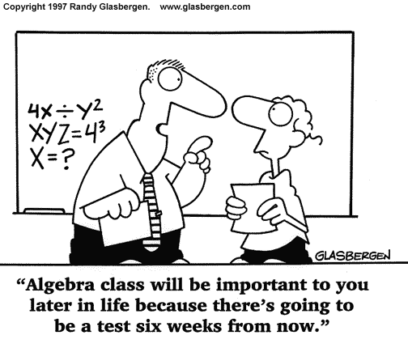
Assignments for Chapter 1

Phone
248-676-8320 ext.7153

Email
Daniel.Miller@hvs.org

Website
www.MrDMillersClassroom.com

