***Pre-Calculus Name_______________***

***Semester 1 Final Exam Review***

**Constructed Response- Calculator Allowed**

1. Given ,
   1. List all possible rational zeros
   2. Using the graph, synthetic division, and factoring/quadratic formula, find all zeros of the function (you must sow work for each zero).
2. Graph the function
   1. Period _______ b. amp___________c. phase shift _____________ d. vert shift __________

e. domain _____________ f. range ________________

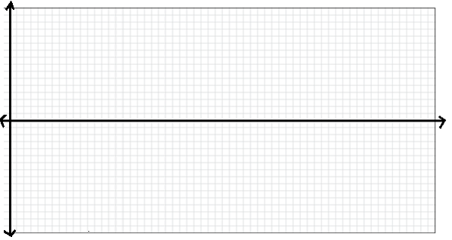

1. Prove the following identity 
2. Solve the following equation for all real numbers 

***Semester 1 Final Exam Review***

**Multiple Choice-Calculator Allowed**

1. You have 600 feet of fencing to enclose a rectangular plot that borders a river. If you do not fence the side along, the river, find the length and width of the plot that will maximize the area. What is the largest area that can be enclosed?
2. Convert to degrees.
3. Use a calculator to evaluate .
4. Find the arc length of the intercepted arc in a circle of radius 13 in. and central angle of 110o.
5. A building that is 21 meters tall casts a shadow 25 meters long. Find the angle of elevation of the sun to the nearest degree.
6. Solve the equation for all real numbers.

**MULITPLE CHOICE SECTION**

**Non-Calculator:**

1. Find the domain of the function 
2. Determine the domain of f+g, f-g, fg, and f/g of 
3. Find when 
4. Write an equation for the inverse function, when 
5. What transformation(s) of , occur based on its parent function?
6. 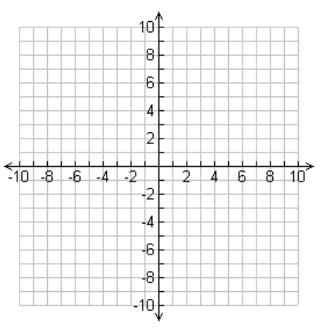Graph  
7. Divide and express the result in standard form 
8. State whether the function crosses or turns around at each x-intercept 
9. Divide and find the remainder 
10. Use Descarte’s Rule of Signs to determine the amount of possible positive and negative zeros for 
11. Find the vertical asymptote(s) of 
12. Solve the rational inequality >0
13. State the correct value for , , , , , , etc.
14. Use the Pythagorean Identity to find , given  and 
15. Find the exact value of the expression 
16. Be able to identify the graphs of each of the six trigonometric functions.
17. Determine the period of 
18. Determine whether the following is True or False: 
19. Determine whether the following is True or False: 
20. Use the identities for cos( x + y ) to evaluate 
21. Find the exact value using identities for: 
22. Find the exact value of , if lies in quadrant I, and  lies in quadrant IV
23. Find the exact value of , if lies in quadrant II
24. Solve for 
25. Solve:  for 