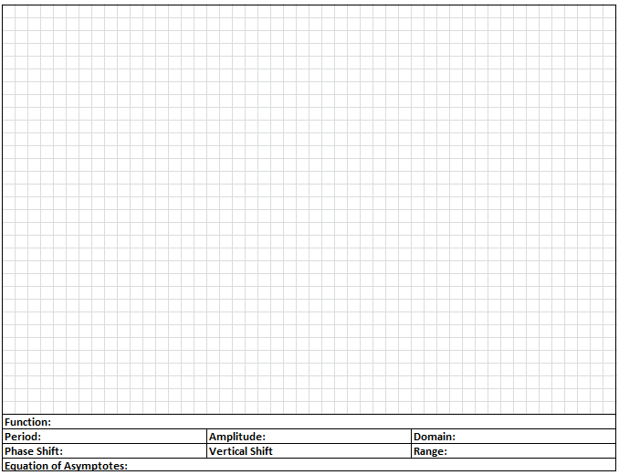
Graphing Sine and Cosine when the Period is not in terms of PI.
$$y=sin\left(πx\right)+3$$

$$y=-2cos(2πx)$$

$$y=3sin\left(\frac{π}{4}x\right)-1$$

$$y=cos(\frac{π}{2}x)+2$$

