Chapter 4 Investigation
Look in chapter for of the book to find most of the information.
1) What are the four ways to CLASSIFY triangles by angle measures?
_____________________________________________________________________________________
_____________________________________________________________________________________
2) What are the three ways to CLASSIFY triangles by side lengths?
_____________________________________________________________________________________
_____________________________________________________________________________________
3) Explain the differences between classifying triangles by their angle measures as opposed to their side lengths.
_____________________________________________________________________________________
_____________________________________________________________________________________
_____________________________________________________________________________________
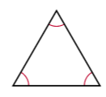
_____________________________________________________________________________________
4) In the following triangle, what does mean?

_____________________________________________________________________________________
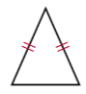
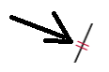
_____________________________________________________________________________________
5) In the following triangle, what does mean?

_____________________________________________________________________________________
_____________________________________________________________________________________
6) What is the SUM of the interior angles of ANY triangle? How do you know? Where did you find it?
_____________________________________________________________________________________
_____________________________________________________________________________________
_____________________________________________________________________________________
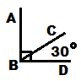
7) Find the measure of angle ABC = ___________

For #8-10, use the figure to the right, classify each triangle by their ANGLE MEASURES.
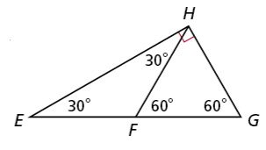
8) Classify $∆FHG$ : ____________
9) Classify $∆GHE$ : ____________
10) Classify $∆HFE$ : ___________

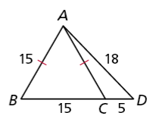
For #11-13, use the figure to the right, classify each triangle by their SIDE LENGTHS.

11) Classify $∆CBA$: ____________
12) Classify $∆DBA$: ____________
13) Classify $∆ACD$: ____________

14) Find the side lengths of equilateral triangle $∆FGH$.
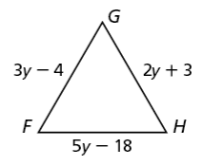
**If segments are congruent, aren’t they also equal? If they are equal, can’t you set them equal to each other?**
FG = _____
FH = _____
GH = _____

