Algebra II Core – First Semester Midterm Review 2016 Part 1
1. Solve the linear system: $\left\{\begin{aligned}2x+3y=-2 \\ 4x+7y=-6\end{aligned}\right.$

2. Graph the linear system and estimate the solution: $\left\{\begin{aligned}3x-y=12 \\ -x+8y=-4\end{aligned}\right.$

3. In one day, a movie theater collected $4600 from 800 people. The price of admission is $7 for an adult and $5 for a child. How many adults and how many children were admitted to the movie theater that day?

4. Solve the system of equations: $\left\{\begin{aligned}4x+5y+3z=15 \\ x-3y+2z=-6 \\ -x+2y-z=3\end{aligned}\right.$

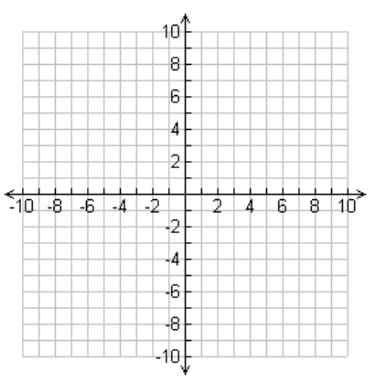
5. Graph the system of linear inequalities: $\left\{\begin{aligned}x+y≥-3 \\ -6x+4y<14\end{aligned}\right.$

6. Which ordered pair is a solution to the system in #7?
a) (-3,1) b) (1,1) c) (0,4) d) (-4,0)

7. Graph the function: $y=(x-2)(x+3)$

8. Write the equation $y=x^{2}+4x-12$ in intercept form of a quadratic.

9. Solve $x^{2}-x=0$

10. Solve ${3x}^{2}+10x-8=0$

11. Describe the end behavior for the graph: ${y=x}^{3}$.

Algebra II Core – First Semester Midterm Review 2016 Part 2
12. Solve ${6x}^{2}-7x=5$. 13. Solve $x^{2}+6x-3=0$.

14. Solve ${(3x-4)}^{2}=60$. 15. Solve $x^{2}+10x+8=-5$.

16. Solve ${4x}^{2}+24x-11=0$ 17. Solve $x^{3}-4x^{2}=0$

18. Graph ${f\left(x\right)=x}^{3}-4x$.

19. Find all of the zeros of the function $f\left(x\right)=3(-x+1)(3x-4)(4x+5)$.

20. Write a polynomial function that has zeros 4, -1, 2 and has a leading coefficient of 1.
A) in intercept form. B) in standard form.

21. Graph $f\left(x\right)=\frac{x+5}{x-2}$.

22. Identify all horizontal and vertical asymptotes of the graph of the function. Find the domain.
$$f\left(x\right)=\frac{x^{2}}{x^{2}-16}$$

23. Add $\frac{12}{x^{2}+5x-24}+\frac{3}{x-3}$

24. Solve. Check for extraneous solutions. $\frac{4}{x+2}=\frac{14}{2x-1}$

25. In the quadratic formula ${y=ax}^{2}+bx+c$, how does “a” affect the graph and how does “c” affect the graph?

27. The price per person of renting a cabin varies inversely with the number of people renting the cabin. It cost $40 per person if 8 people rent the cabin. How much will it cost per person if 12 people rent the cabin?

