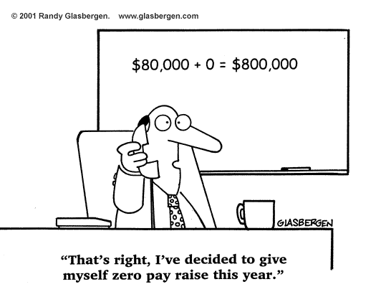
Assignments: Sections 4.1-4.3
Mr. Miller
Daniel.Miller@hvs.org
248-676-8320 ext. 7153
http://mrdmillersclassroom.weebly.com/pre-calc

 | 4.1 | 4.2 | 4.3
Wednesday  10/15/2014 | 1-40  Skip 7-12
Thursday  10/16/2014 | Unit Circle: YOU MUST MEMORIZE THIS
Friday  10/17/2014 |  | 5-24
Monday  10/20/2014 | 41-69 odd  71-76 all
Tuesday  10/21/2014 |  | 25-46
Wednesday  10/22/2014 |  |  | 1-41 odd
Thursday  10/23/2014 |  |  | 53-60 all
Friday  10/24/2014 | Chapter Review 1-43 odd  Unit Circle Test Attempt 1
Monday  10/27/2014 | Question & Answer Session for Test 4.1-4.3  Unit Circle Test Attempt 2
Tuesday  10/28/2014 | Test 4.1-4.3  This test contains both calculator allowed and no calculator allowed portions

