Assignments: Chapter 9 – Conic Sections

Mr. Miller – PreCalculus

Daniel.Miller@hvs.org

248-676-8320 ext. 7153

www.mrdmillersclassroom.weebly.com

|  |  |  |  |  |  |
| --- | --- | --- | --- | --- | --- |
|  | **9.1** | **9.2** | **9.3** | **9.5** | **9.6** |
| **Monday**  **4-20-13** | Worksheet –  Circles and Ellipses |  |  |  |  |
| **Tuesday**  **4-21-13** |  | Worksheet - Hyperbolas |  |  |  |
| **Wednesday**  **4-22-13** | 25-53 EOO | 27-47 EOO |  |  |  |
| **Thursday**  **4-23-13** |  |  | Worksheet - Parabolas |  |  |
| **Friday**  **4-24-13** |  |  |  | 1-33 EOO |  |
| **Monday**  **4-27-13** |  |  |  | 41, 42, 43, 44, 45, 46, 47,48, 49, 50 |  |
| **Tuesday**  **4-28-13** |  |  |  |  | 1 – 19 Odd |
| **Wednesday**  **4-29-13** | Review Worksheet | | | | |
| **Thursday**  **4-30-13** | Q & A Review | | | | |
| **Friday**  **5-1-13** | Quiz Chapter 9 | | | | |

End of Term 5: Friday, April 24!

The 9:1-2 Assignments must be turned in by then as they will go on term 5. The 9-3, 9-4, 9-5 Assignments must be turned in by Wednesday 4/29 and will go on term 6. The Chapter 9 Quiz will also go on term 6.

Conic Sections - Circles and Ellipses Name: _________________________________

1. Find the equation of a circle with diameter endpoints (4, 5) and (6, 1).
2. Find the equation of a circle with center (5, -3) and tangent to the x-axis.
3. Find the equation of a circle with center (-4, 6) and tangent to the y-axis.
4. Find the center, radius of the circle, and graph. 6. Find the center, radius, and graph of the circle.

 

 

1. Find the standard form of the equation of the ellipse with a horizontal major axis of length 8 and minor axis of length 4, center at (-1, 3)
2. Find the center, vertices, co-vertices, 8. Find the standard form of the ellipse, then find the

foci, and graph of the ellipse. center, vertices, co-vertices, foci, and graph.

 

 

1. Write the equation in standard form. 10. Find the solution of the system of equations by graphing.

 

 The equation of the ellipse is . Write an equation for

Conic Sections - Hyperbolas Name: _________________________________

1. Find the equation of a hyperbola with Center (4, -2), Focus (7, -2) and Vertex (6, -2).
2. Find the equation of a hyperbola with Foci (0,-3), (0,3) and Vertices (0,-1), (0, 1).
3. Find the equation of the hyperbola below:

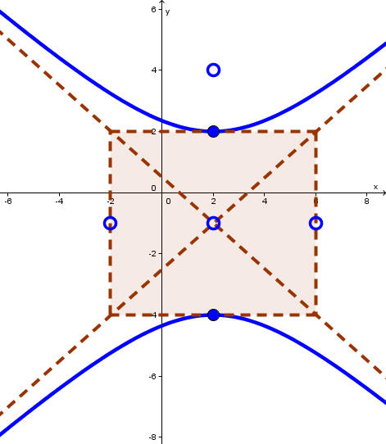

1. Find the center, vertices, asymptotes, foci and graph. 5. Find the center, asymptotes, vertices, foci, and graph

 

 

1. Find the equation of a hyperbola with the x-axis as its transverse axis, point (3, 1) lies on the graph of this hyperbola and point (4, 2) lies on the asympotote of the hyperbola.

Convert the equation to standard form, then graph and find all necessary information.

1.  8. 



Find the solution to the system by graphing.

1.   10. 
2. An architect designs two houses that are shaped and positioned like a part of the branches of the hyperbola whose equation is  , where x and y are in yards. How far apart are the houses at their closest point?