Assignments: Sections 6.1-6.2 and 6.6-6.7

Mr. Miller – PreCalculus
Daniel.Miller@hvs.org
248-676-8320 ext. 7153
www.MrDmillersclassroom.weebly.com

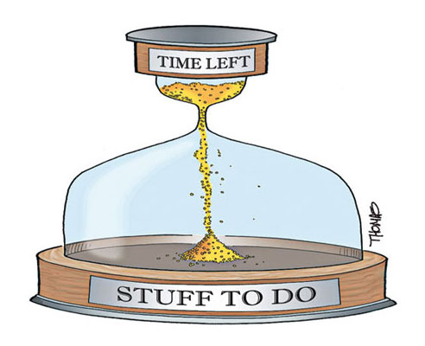
 | 6.1 p651 | 6.2 p661 | 6.6 p709 | 6.7 p719
Monday  1/25 | p651 1-15 odd
Tuesday  1/26 | P652 17-29 odd
Wedensday  1/27 |  | 1-28 odd
Thursday  1/28 |  |  | 21-37 odd, 47, 49, 51 | 1-7 odd, 17-21 odd
Friday  1/29 | Work On Review Sheet
Monday  2/1 | Go over Review Sheet
Tuesday  2/2 | Quiz 6:1-3, 6-7

