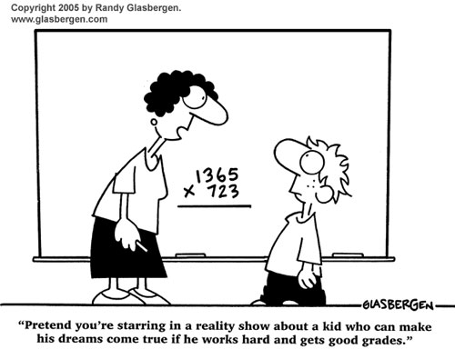
Assignments: Section 2.4-2.8

Mr. Miller – PreCalculus
Daniel.Miller@hvs.org
248-676-8320 ext. 7153
www.mrdmillersclassroom.weebly.com

 | 2.4 p324 | 2.5 p336 | 2.6 p354 | 2.7 p366 | 2.8 p376
9/30/16 | 5 – 37 EOO,  41, 45
10/3/16 |  | 1-21 EOO
10/4/16 |  | 34-36,  53-60
10/5/16 |  |  | 21-35 odd  Vert & Horiz Asym.
10/6/16 |  |  | 61-67, 71-77odd
10/7/16 |  |  | Graphing Worksheet
10/10/16 |  |  |  | 1-57 EOO
10/11/16 |  |  |  | 3-59 EOO
10/12/16 |  |  |  |  | 1-10, 21-30
10/13/16 | Chapter Review pg 385 #11-29 (answers at the end of hour)
10/14/16 | Quiz Review Worksheet
10/17/16 | Q&A
10/18/16 | Test 2.4-2.8  includes both calculator allowed and no calculator allowed portions

