Conic Sections - Parabolas Name: _________________________________

1. Find the equation of a parabola with focus (7, 0) and directrix x = -7.
2. Find the equation of a parabola with focus (7, -2) and Vertex (5, -2).
3. Find the equation of the parabola below:

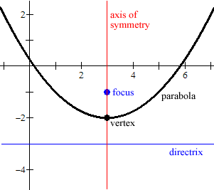

1. Find the Vertex, focus, directrix, and graph. 5. Find the vertex, focus, directrix, and graph.

 

 

Convert the equation to standard form, then graph and find all necessary information.

1.  7. 



Find the solution to the system by graphing.

1.   9. 
2. Determine the functions domain and range. 