Law of Sines Worksheet #2
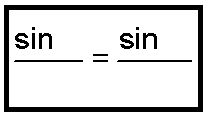
Use the Law of Sines to solve for each of the following sides. Complete the proportion for each first. After one of your teachers has checked your proportions and your proportions are correct, THEN you may move on to solving the equations.
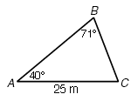
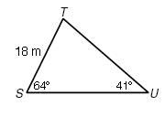
1) Find TU = _____ 2) Find BC = _____

3) Find NP =_____ 4) Find FE = _____
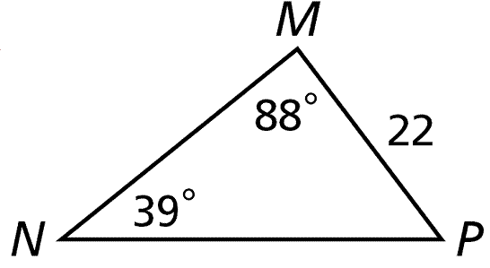
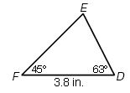

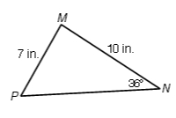
5) Find the measure of angle P = _____ 6) Find the measure of angle T = _____
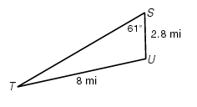

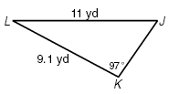
7) Find the measure of angle J = _____ 8) Find the measure of angle R = _____
