Conic Sections - Hyperbolas Name: _________________________________

1. Find the equation of a hyperbola with Center (4, -2), Focus (7, -2) and Vertex (6, -2).
2. Find the equation of a hyperbola with Foci (0,-3), (0,3) and Vertices (0,-1), (0, 1).
3. Find the equation of the hyperbola below:

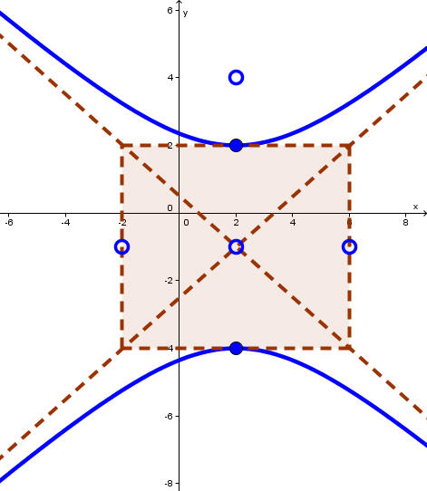

1. Find the center, vertices, asymptotes, foci and graph. 5. Find the center, asymptotes, vertices, foci, and graph

  

1. Find the equation of a hyperbola with the x-axis as its transverse axis, point (3, 1) lies on the graph of this hyperbola and point (4, 2) lies on the asympotote of the hyperbola.

Convert the equation to standard form, then graph and find all necessary information.

1.  8. 



Find the solution to the system by graphing.

1.   10. 
2. An architect designs two houses that are shaped and positioned like a part of the branches of the hyperbola whose equation is  , where x and y are in yards. How far apart are the houses at their closest point?