1) Solve the proportion $\frac{18}{x}=\frac{7}{4}$

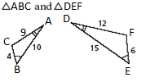2) Determine if the triangles are similar, and if so what is the similarity ratio (largest to smallest)?

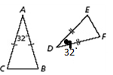3) Why are the two triangles similar and what is the correct similarity statement?

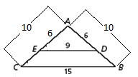

4) Explain why the triangles are similar and then find AB.

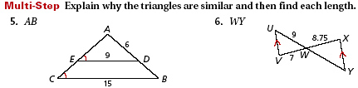

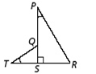5) Explain why the triangles are similar and write a similarity statement.

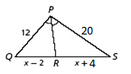

6) Find QR.

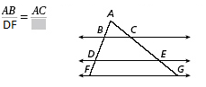7) Fill in the blank.

8) The scale of this model of the space shuttle is 1ft : 40 ft. In the actual space shuttle, the main cargo bay measures 20 ft wide by 80 ft long. What is the length of the cargo bay in the model?

9) The ratio of the side lengths of a triangle is 4:6:8 and its perimeter is 54 cm. What is the length of the shortest side?

10) Write a proportion for the following given segments to be parallel.

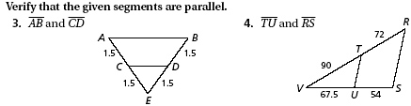

11) Use Pythagorean Theorem to find the value of *x*. Round to the nearest hundredth.

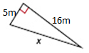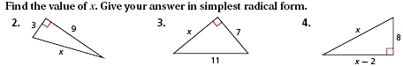

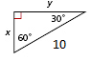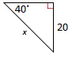12) Find the value of x. (SOHCAHTOA) 13) Find the value of x and y.

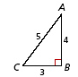

14) Find cos A. Leave your answer as a fraction.

15) Use special right triangles to find the value of tan . Leave your answer as a simplified fraction.

16) Use the Law of Sines to find . Round to the nearest tenth.

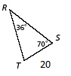

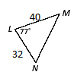

17) Use the Law of Cosines to find . Round to the nearest tenth.

18) Find the sum of the vectors: <4,5> and <5,0>.

19) Write the vector  in component form. 20) What are equal vectors?

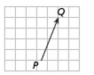

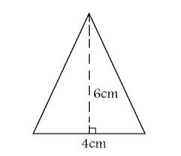 21) Finding area of all shapes.

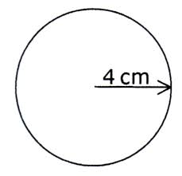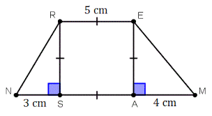

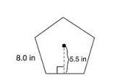

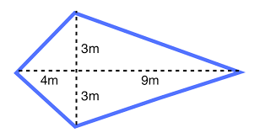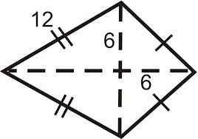

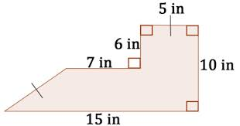

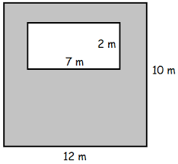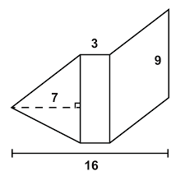22) Find the area of composite figures.

23) One rectangle has a length and width of 3 and 4. Another rectangle has a length and width of 15 and 20. Find the ratio of the **areas** of the rectangles.

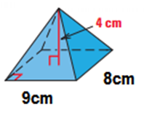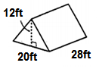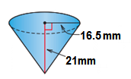24) Find the Surface area and Volume of each of the following.

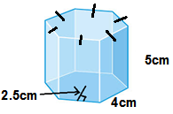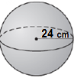

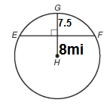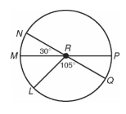25) Find the measure of arc QM. 26) Find the length of EF.

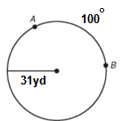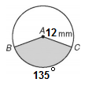27) Find the area of the sector. 28) Find the arc length.

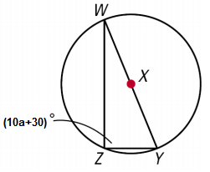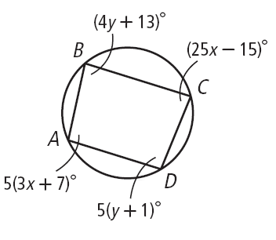29) Find the measure of each angle. 30) Find a = ____.

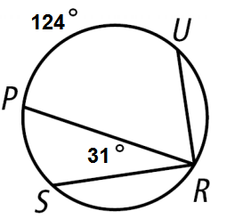

31) Find the measure of angle PRU = _____ and the measure of arc PS = _____.