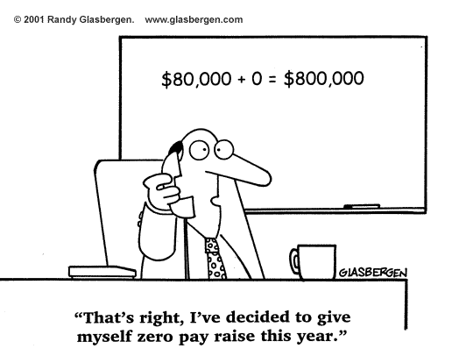
Assignments: Sections 4.1-4.3
Mr. Miller- PreCalculus
Daniel.Miller@hvs.org
248-676-8320 ext. 7153
www.MrDMillersClassroom.weebly.com
 | 4.1 p473 | 4.2 p486 | 4.3 p498
Wed. 10/19 | 1-40 skip 7-12  41-69 odd  71-76 all
Thur. 10/20
Fri. 10/21 |  | 5-38 all
Mon. 10/24
Tues. 10/25 |  | 4.2 Worksheet  *Start preparing for the Unit Circle Test*  Test is Friday
Wed. 10/26 |  |  | 1-41 odd
Thur. 10/27 |  |  | 53-60 all
Fri. 10/28  ½ Day | Unit Circle Test Attempt 1  Start: Chapter Review 1-43 odd
Mon. 10/31 | Finish Chapter Review 1-43 odd
Tues. 11/1 | Question & Answer Session for Test 4.1-4.3  Unit Circle Test Attempt 2
Wed. 11/2 | Test 4.1-4.3  This test contains both calculator allowed and no calculator allowed portions

***November 4th is the last day of Term 1. It is also the last day to turn in any assignments for Term 1.
****If you miss the test on 11/2, you must take by 11/4!!

