Name ______________________ 4.4 & 4.6 Review WKST 1 Date ______ Hour ____

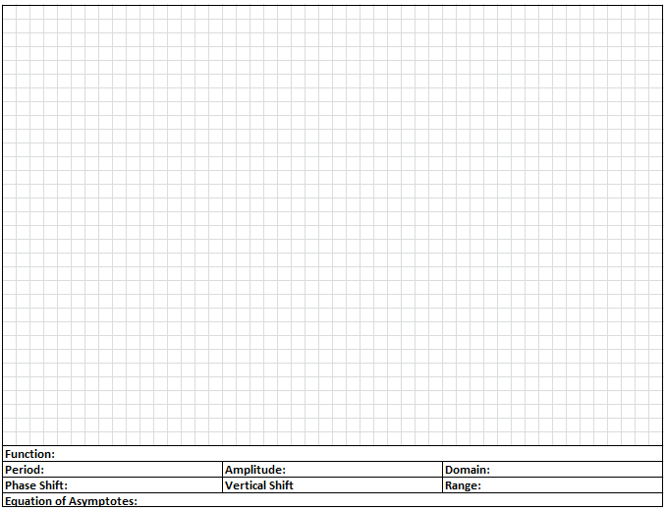1. Graph one cycle of the basic function and then graph



2. Graph one cycle of the basic function and then graph



3. Graph one cycle of the basic function and then graph

4. Graph one cycle of the basic function and then graph



5. Graph one cycle of the basic function and then graph





6. Graph one cycle of the basic function and then graph





7. Graph one cycle of the basic function and then graph



8. Graph one cycle of the basic function and then graph



